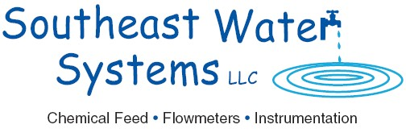 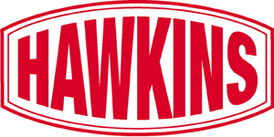

September 20, 2021

Dear Valued Southeast Water Systems Customers:

We are pleased to announce that **Southeast Water Systems, LLC** has agreed to sell its assets to **Hawkins, Inc.** as of September 20, 2021. Hawkins, Inc. distributes, blends and manufactures chemicals and other specialty ingredients chemicals for its customers in a wide variety of industries. Headquartered in Roseville, Minnesota, and with 45 facilities in 23 states, Hawkins is a publicly traded company (Nasdaq: HWKN). Like Southeast Water Systems, Hawkins creates value for its customers through superb customer service and support, quality products and customized applications.

We assure you that our goal is to avoid any disruption in the conduct of your business with Southeast Water Systems, and to continue giving you all the benefits you enjoy from doing business with Southeast Water Systems while adding the greater strength and deeper product availability which Hawkins brings. The same employees will continue to support you in the same ways we have for many years. We remain committed to continue to deliver the high-quality service and satisfaction to which you are accustomed.



We intend to use Hawkins’ expertise and broad product offerings to expand the products and services that we can offer to you. We look forward to working with you to better define those opportunities.

We sincerely want to thank you for your continued business and support. If you have any questions, please do not hesitate to call your contact person or either of us.





Southeast Water Systems, LLC Hawkins, Inc.

Andy McKeown Patrick Hawkins

President Chief Executive Officer and President